NeuroPhoenix Site Plan

Lauren Seacrist

WDD 130

Overview

Purpose

NeuroPhoenix is to provide a supportive, educational, and empowering resource for autistic and ADHD individuals, as well as those seeking to better understand neurodiversity. Our website aims to combine research-based information with personal lived experiences to help visitors navigate everyday challenges, build self-advocacy skills, and develop a deeper understanding of neurodivergent experiences. Inspired by the symbolism of the phoenix, the website emphasizes resilience, growth, and the ability to rise above challenges while embracing one's authentic self. We also plan on diving into both practical topics and more complex issues such as ableism, trauma, communication differences, and personal growth. We plan on providing articles, resources, personal insights, and coping strategies. We exist to help promote understanding, confidence, and provide a greater sense of belonging for neurodivergent individuals and their communities.

Audience
The primary audience includes autistic and ADHD teens and adults, particularly those with Level 1 Autism Spectrum Disorder or similar support needs, as well as individuals navigating the effects of trauma, masking, burnout, self-advocacy, and personal growth. The website is intended for neurodivergent individuals who are seeking research-based information, lived experiences, practical strategies, and a deeper understanding of how neurodiversity can intersect with everyday life and trauma-related experiences.

The secondary audience includes parents, family members, educators, employers, mental health professionals, friends, and allies who want to better understand neurodiversity and learn how to provide meaningful support. Visitors may range from those newly discovering they are neurodivergent to those seeking deeper discussions about resilience, healing, self-acceptance, communication differences, and the process of rising above adversity.

Please note that while NeuroPhoenix welcomes all visitors, its content is primarily informed by the lived experiences of individuals with Level 1 Autism, ADHD, and trauma-related challenges. Thank you for understanding.

Branding

Website Logo


Style Guide

Color Palette
Primary – Dark Crimson | Secondary - Deep Red | Accent 1 – Electric Pink | Accent 2 – Muted Red
#1e0509 | #2e02c12 | #ff1f6e | #3d1018
Accent 3 – Dusty Rose | Accent 4 – Blush White
#c47080 | #ffe8ec

Typography

Heading/Display Font: BARLOW CONDENSED

Paragraph Font | DM Sans

“Quote Font | DM Serif Display”

Navigation
Home About Me Blog Say Hi!

Content | Home Page Preview

NOTE | Social Buttons will be on every page

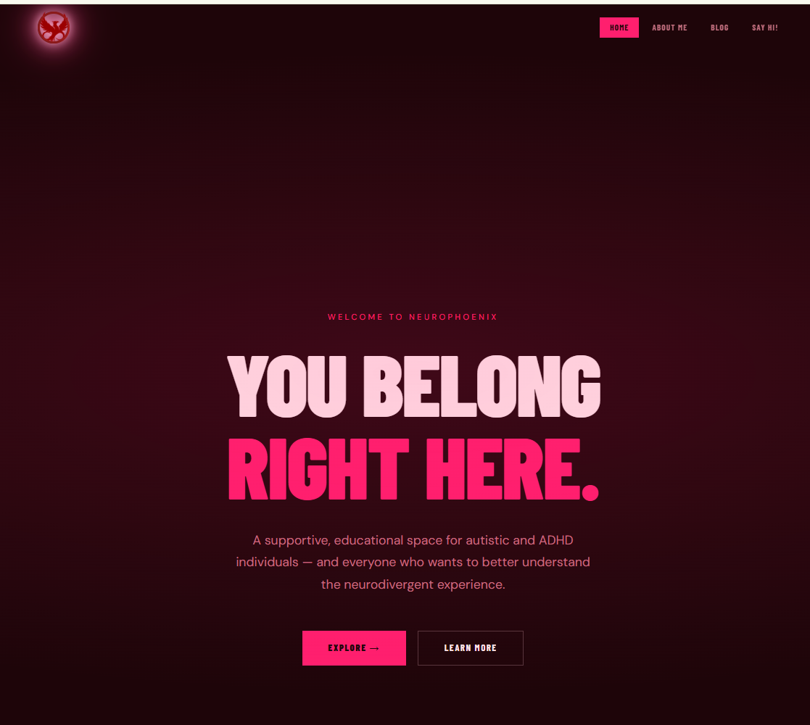
Blog Content Preview

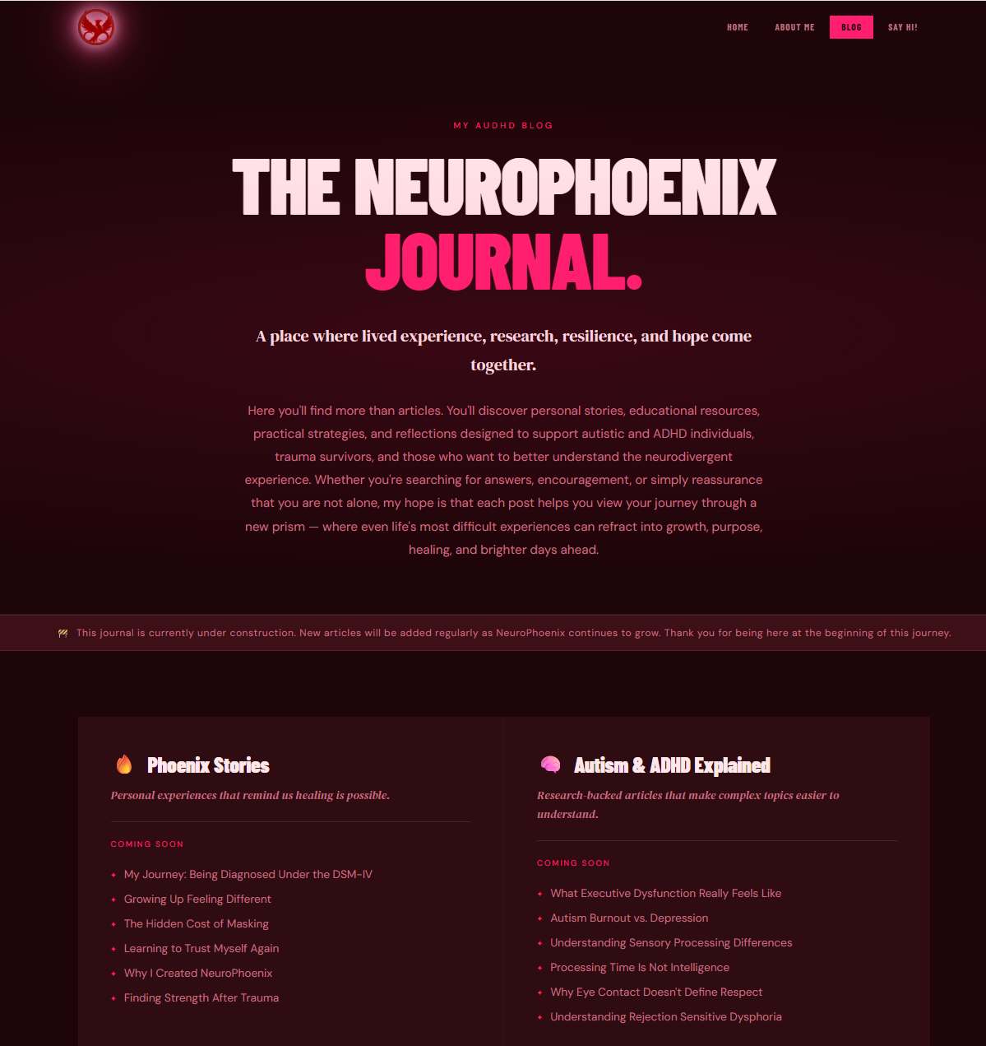

About Me | Content Preview

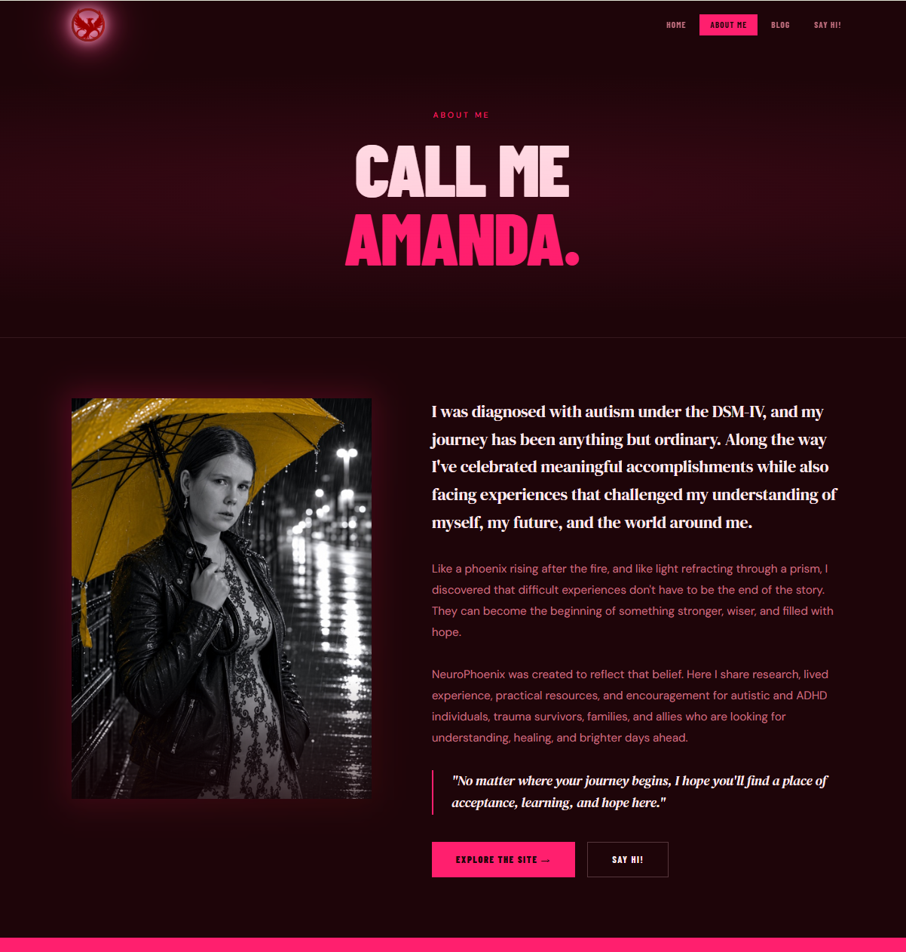

Wireframes | Home page

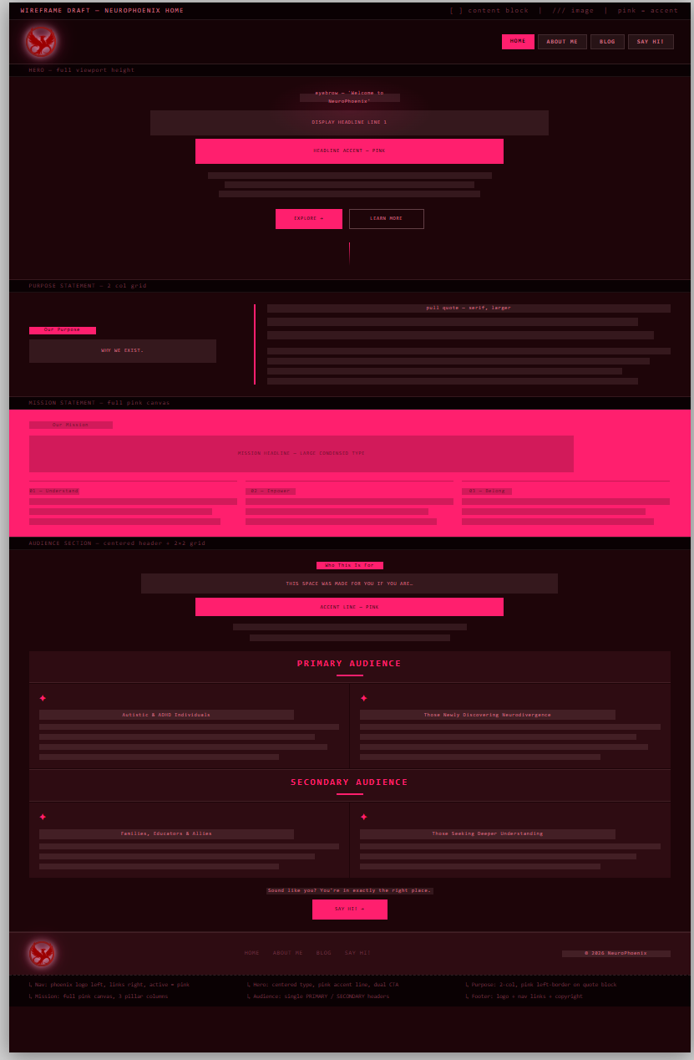

Wireframes | About me page
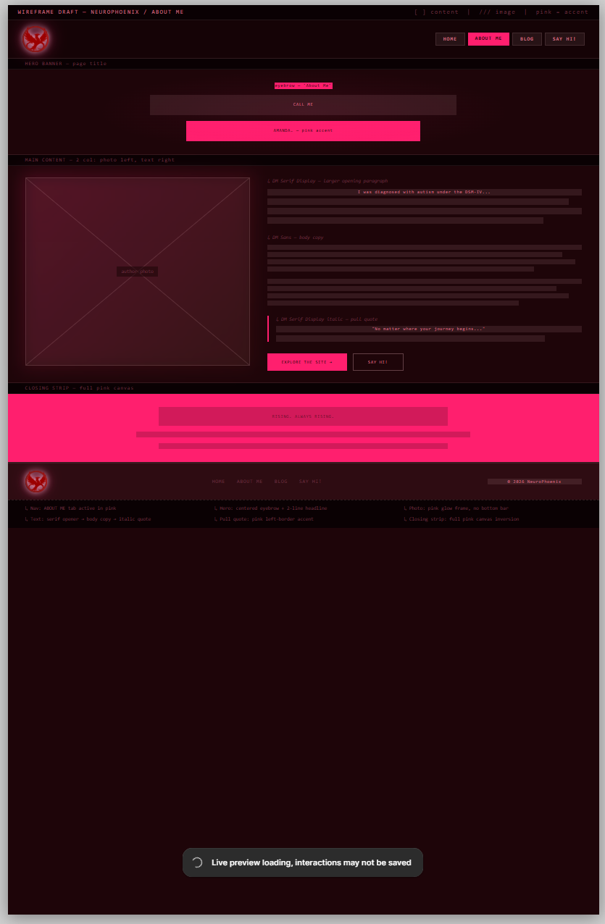

Wireframes | Blog page
